50ᵀᴴ INTERNATIONAL SWIMMING CHAMPIONSHIPS “RADOVLJICA 2026”

RADOVLJICA, 4th. – 5th. of July 2026

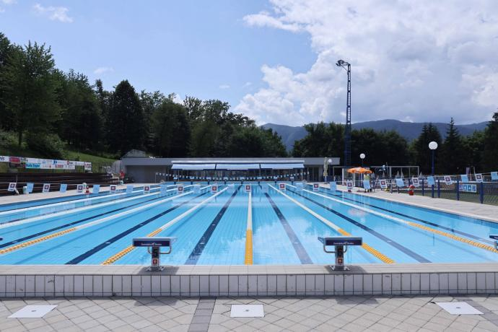

Organizer of the 50th International swimming championships ‘RADOVLJICA 2026’':

Plavalni klub Radovljica, p.p. 83

SI-4240 Radovljica, Slovenia

E-mail: pkrad@plavalniklub-radovljica.si

URL:www.plavalniklub-radovljica.si

The 50th international swimming championships ‘RADOVLJICA 2026" will be held on Saturday, 4th of July 2026, and Sunday, 5th of July 2026, with heats in the morning and finals in the afternoon. The best eight (8) swimmers from the morning heats irrespective of the category will appear in the finals. The exception is 800m freestyle and 1500 m freestyle and 400m medley, which are held as direct finals.

In the afternoon, on Saturday, 4th July 2026, and Sunday, 5th July 2026, will be finals A, B and C.

In A finals will appear the best eight (8) swimmers from the morning heats in the categories A+B+C+D

In B finals will appear the best eight (8) swimmers from the morning heats, in the categories C+D,

In C finals will appear the best eight (8) swimmers from the morning heats in the categories D

Place of competition:

SWIMMING POOL RADOVLJICA, UNDER OBLA GORICA

Kopališka 9

SI-4240 Radovljica
- −length: 50m, width: 21m; depth: from 1,35m to 1,85m
- −8 lanes −water temperature: 26.5 °C

Time is measured electronically by PZS TIMING

The competition is governed by the PZS and EA & WA regulations.

The rule of one (1) start applies.

In the heats the swimmers will be ranked according to the entered results previously achieved in the long course competitions irrespective of the category .

Entry fee for each entered start amounts to 8 EUR and is to be settled by the clubs’ representatives (with exception of the invited clubs) prior to the competition on the following Bank account:

IBAN: SI56 0700 0000 1128 491
BIC (SWIFT) code: GORESI2X

Official address of our bank:
GORENJSKA BANKA, d.d.
Bleiweisova cesta 1
4000 Kranj

The right to participate in the competition is granted to male and female swimmers registered with the national swimming associations that are members of WA (WORLD AQUATICS). All competitions are open to competitiors from clubs and national associations that are members of the World Aquatics (WA).

Categories:

CATEGORY | FEMALE | MALE
A - open | 14 YEARS AND OLDER
B U 23 | 23 YEARS – 19 YEARS
C | 18 YEARS & 17 YEARS
D | 16 YEARS & 15 YEARS AND YOUNGER

Prizes:

Category A, B, C, D will be awarded medals in the afternoon finals according to the times swam in the finals.

Best three female and male swimmers in a OPEN category - 4 best results in both final days (two from Saturday and two from Sunday) according to WA POINTS will be awarded with money prizes.

- Place - 500EUR 2. Place - 300EUR 3. Place - 100EUR

Deadline for entries: 29th June 2026

Entries should be sent to e-mail: pkrad@plavalniklub-radovljica.si

Accomodation

LIFE HOTELS “ HOSTELS; Kranjska cesta 2 44240 Radovljica

e-mail: info@life-hostel-slovenia.com

mobile: 00386440531547

Program of the competition:

SATURDAY, 4th July 2026 - Heats: Warm-up: 8.00, Start of heats: 9.00

400m | medley | M,W | direct finals
50m | breaststroke | M,W | heats
200m | freestyle | M,W | heats
100m | butterfly | M,W | heats
100m | backstroke | M,W | heats
200m | breaststroke | M,W | heats
50m | freestyle | M,W | heats
1500m | freestyle | M | direct final (max 2 groups)
800m | freestyle | W | direct final (max 2 groups)

Finals:Warm-up: 16.00, Official opening: 16.45, Start of finals: 17.00

1500m | freestyle | M | fastest heat
800m | freestyle | W | fastest heat
50m | breaststroke | M,W | FINALS A,B,C
200m | freestyle | M,W | FINALS A,B,C
100m | butterfly | M,W | FINALS A,B,C
100m | backstroke | M,W | FINALS A,B,C
200m | breaststroke | M,W | FINALS A,B,C
50m | freestyle | M,W | FINALS A,B,C
400m | medley | M,W | fastest heat

SUNDAY, 5th July 2026 - Heats: Warm-up: 8.00, Start of heats: 9.00
200m | medley | M,W | heats
50m | backstroke | M,W | heats
400m | freestyle | M,W | heats
100m | freestyle | M,W | heats
200m | butterfly | M,W | heats
200m | backstroke | M,W | heats
100m | breaststroke | M,W | heats
50m | butterfly | M,W | heats
1500m | freestyle | W | direct final (max 2 groups)
800m | freestyle | M | direct final (max 2 groups)

Finals: Warm-up: 16.00, Start of finals: 17.00
1500m | freestyle | W | fastest heat
800m | freestyle | M | fastest heat
200m | medley | M,W | FINALS A,B,C
50m | backstroke | M,W | FINALS A,B,C
400m | freestyle | M,W | FINALS A,B,C
100m | freestyle | M,W | FINALS A,B,C
200m | butterfly | M,W | FINALS A,B,C
200m | backstroke | M,W | FINALS A,B,C
100m | breaststroke | M,W | FINALS A,B,C
50m | Butterfly | M,W | FINALS A,B,C

