INTERNATIONAL SWIMMING COMPETITION » MEMORIAL JOŽETA REBCA 2025«

RADOVLJICA, JUNE 6. 2026

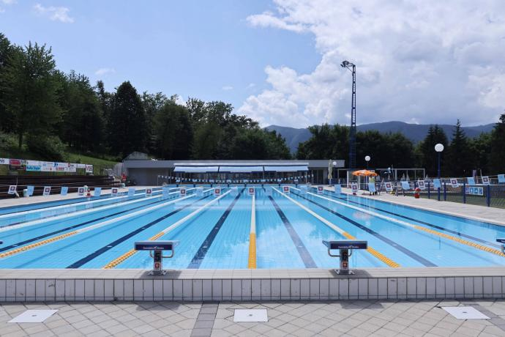

Organizer of the International swimming competition ‘MEMORIAL JOŽETA REBCA 2026’':

Plavalni klub Radovljica, p.p. 83

SI-4240 Radovljica, Slovenia

E-mail: pkrad@plavalniklub-radovljica.si
URL:www.plavalniklub-radovljica.si

International swimming competition ‘MEMORIAL JOŽETA REBCA 2026’'will take place on
SATURDAY, JUNE 6, 2026, with both morning and afternoon sessions

Place of competition:

OLYMPIC SWIMMING POOL RADOVLJICA,

Kopališka 9; SI-4240 Radovljica
- −length: 50m, width: 21m; depth: from 1,35m to 1,85m
- −8 lanes
- −water temperature: 26.5 °C

Time is measured electronically by PZS TIMING

The competition is governed by the PZS and WA regulations.

The rule of one (1) start applies.

In the heats the swimmers will be ranked according to the entered results previously achieved in the long course competitions irrespective of the category .

Entry fee for each entered start amounts to 8 EUR and is to be settled by the clubs’ representatives (with exception of the invited clubs) prior to the competition on the following Bank account:

IBAN: SI56 0700 0000 1128 491
BIC (SWIFT) code: GORESI2X

Official address of our bank:
GORENJSKA BANKA, d.d.
Bleiweisova cesta 1
4000 Kranj

The right to participate in the competition is granted to male and female swimmers registered with the national swimming associations that are members of WA (WORLD AQUATICS). All competitions are open to competitors from clubs and national associations that are members of the World Aquatics (WA).

CATEGORY | FEMALE | MALE
BOYS / GIRLS | A-14years , B-13 years | A-14years , B-13 years
YOUNG BOYS / YOUNG GIRLS | C-12 years, D-11 years, E-10 years | C-12 years, D-11 years, E-10 years
CICBANI / CICIBANKE | F – 9 years and younger | F – 9 years and younger
Awards and Prizes:
The top three male and female swimmers in each category and discipline will receive medals. Medals will be presented after every second completed event.

In the memorial event:
- 200m Backstroke: A trophy will be awarded to the overall winner (male and female) in the following categories – Boys A & B; Girls A & B; Younger Boys B & C; Younger Girls B & C.
- 100m Backstroke: A trophy will be awarded to the overall winner (male and female) in the following categories – Younger Boys E & Boys F; Younger Girls E & Girls F.

Program OF THE COMPETITION:

SATURDAY, JUNE 7. 2025
- PART: WARM UP: 8.00, START OF COMPETITION : 9.00

50m free m, ž A, B, C, D, E, F
200m medlay m, ž A, B, C, D
100m breast m, ž E, F
200m free m, ž A, B, C, D
50m breast m, ž A, B, C, D, E, F
100m free m, ž E, F
800m free m,ž A, B, C, D, (max 4 groups in male and female kategory)

- PART: WARM UP: 15.00, START OF COMPETITION : 16.00

50m fly m,ž A, B, C, D, E, F
200m breast m,ž A, B, C, D
50m back m,ž A, B, C, D, E, F
200m fly m, ž A, B, C, D
100m back m, ž E, F – memorial event
200m back m,ž A, B, C, D – memorial event

Deadline for entries: JUNE 1th. 2026 Entries should be sent to e-mail: pkrad@plavalniklub-radovljica.si

Accomodation:

LIFE HOTELS “ HOSTELS; Kranjska cesta 2 44240 Radovljica

e-mail: info@life-hostel-slovenia.com mobile: 00386440531547

